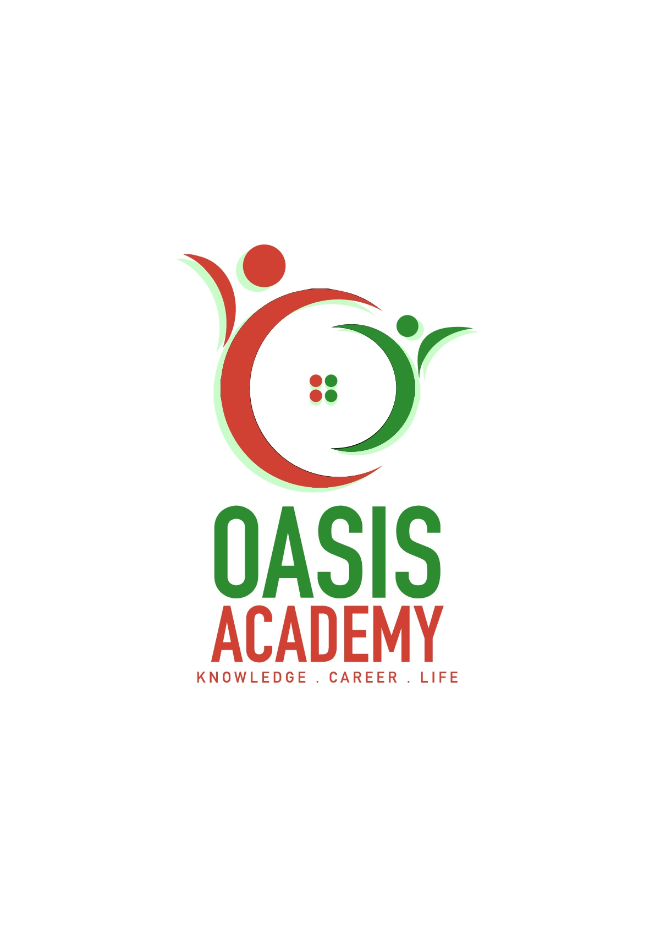

Name: Lim Yee Hwee

Login ID: limyee@oasis-portal.com

Course title: Essential of Huma Resource

Subject Code: BHM01

Submitted date: 05-06-2017

**Table of Contents**

|  |  |  |
| --- | --- | --- |
| **No** | **Details** | **Page** |
| 1 | Executive Summary | 2 |
| 2 | Introduction | 3 |
| 3 | Assignment Question |  |
|  | Part 1 | 4-5 |
|  | Part 2 | 6-7 |
|  | Part 3 | 8 |
|  | Part 4 | 9-10 |
| 4 | Conclusion | 11 |
| 5 | References | 12 |
|  |  |  |

**Executive Summary**

In this assignment, I studied about essentials of human resources management. Human resources is a staff or employee in a organization. At the beginning, I want to introduction the questions. First part, I learned to describe the major activities and human resources in hospitality management. In the second part, I understand in brief of human resources planning and planning trend in hospitality. Furthermore, I understanding on action plan human resource planning in hotel industry. The third part, I covered the topic about human resources functions and human resources policies. I learned the functions of management and the policy applies accordingly in hospitality management. In the fourth part, I studied about organizational behavior in hospitality and brief on groups and structure in organization.

**Introduction**

In this assignment, I need to talk about human resource management. Human resource management refers to the management of the tasks involved in human or personnel matters in the management process. Human resource management includes: job analysis, development of human needs planning and recruitment, training and development, compensation and welfare management, performance evaluation, labor relations management. And I will talk about the important of human resource management. Human resources management is the source of enterprise development momentum, is the fundamental guarantee for sustainable development of enterprises. Human resources management according to the status quo and future of the enterprise, there are plans and objectives to carry out the work, the management staff, employees put forward the work requirements. Strengthen the management of enterprise culture and improve the quality of staff to strengthen human resources management.

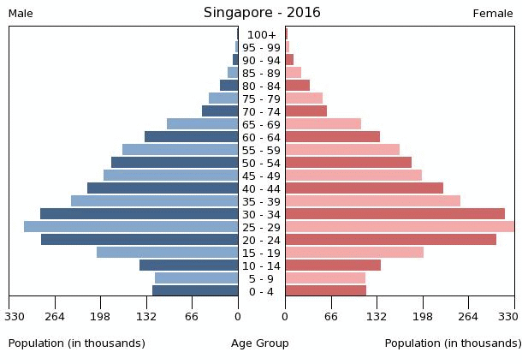

Figure 1 Index Mundi (2016)

According to the above chart you can see that there are a lot of young people have chosen in Singapore, so that the side of the human resources is very good.

**Assignment Questions**

Questions 1

Define the Major Activities and Human Resources Operation in Hospitality Management.

Human Resources Management is comprise to employee, human resource planning, employee relationship management, knowledge and skills. Hiring employee is to improve the quality of, to cultivate a employee be provided with a good attitude, train the employee must have responsibility and a diligent work attitude so that they can become more valuable to the company. Employee relationship management in company human resource system is through the formulation and implementation of human resources policies and management practices, as well as other management means of communication to adjust the company and employees, employees and employees of the interconnected and affect, in order to achieve the objectives of the organization and to ensure that employees, and add the social value.

The major activities of human resource management department comprise to five points it is recruiting, training, compensation, motivation and evaluation.

The first point is recruiting, recruiting is the core skills of human resource management. Recruiting refers to the process of attracting, selecting and appointing suitable work candidates throughout the organization as a permanent or temporary whole process. Recruiting can also refer to individual candidates who are engaged in unpaid positions, such as voluntary roles or unpaid trainees. Managers, Human and recruiters may be responsible for the recruitment process, but in some cases, public sector employment agencies, business recruitment agencies or expert search advisory bodies are used to undertake part of the process. Support for recruiting all aspects of Internet technology has become popular.

The next point is training, training is to teach or develop yourself or other skills and knowledge related to specific usability. Training has a specific goal of improving capacity, productivity and performance. It forms the core of the apprentice and provides the backbone of the content technically. In addition to the basic training required for trade, occupation or the labor market observers recognize in the occupation that training needs to continue beyond the initial qualification is to maintain, upgrade and update the skills of the whole work life. Many professionals can view this training as a professional development.

The third point is compensation, compensation is commissions, bonuses, management grants, accident insurance, pension funds, paid leave and other allowances. The increase and decrease in staff will be affected by the level of compensation. Management grants will be divided into many different grades because of the team's performance. The bonus points for each shift are the focus of the comparison between companies. Each company will have different benefits to the staff to provide protection. Rank or work time to enjoy the benefits of the project and the impact of high and low, in general, the higher rank and the longer the work time to enjoy the more benefits, and the higher amount. Bonuses will be based on the company's performance during the period as a regular compensation. It can also encourage employees to buy the discount at the price.

The fourth point is motivation, motivation is the level of desire employees feel to perform, regardless of the level of happiness. Employees who are adequately motivated to perform will be more productive, more engaged and feel more invested in their work. The process through which managers encourage employees to be productive and effective. As a motivated employees must be friendly and creating a pleasant transaction that makes you more likely to return. Process the transaction quickly that mean at the company can serving more customers and also can suggest an additional item you would like to purchase, increasing sales for the company.

The last point is evaluation, evaluation is to systematically determine the value, value and meaning of the subject, using a set of standard management standards. It may assist in organizing, planning or other interventions or initiatives to evaluate any objectives, achievable concepts or any alternatives to decision making; or to determine the degree of achievement or value of the goals and objectives and results of any such action that has been completed. The main purpose of the assessment, in addition to gaining insight into previous or existing initiatives, is to reflect on and assist in identifying future changes. Assessments are often used to describe and evaluate the interest of a wide range of human enterprises, including arts, criminal justice, foundations, nonprofit organizations, governments, health care and other human services. It is long and finished over a period of time.

Question 2

Describe in brief on Human Resources Planning and Planning Trend in Hospitality.

Explain about what is your understanding on Action Plan Human Resource Planning in Hotel Industry.

Human Resources Planning is company from the strategic planning and development goals, according to its internal and external changes in the environment, to predict the future development of human resources needs, as well as to meet the needs of human resources to provide the activities of the process. In order to ensure the practicality and effectiveness of the enterprise human resources plan, the HR plan will pay more attention to the key link statements. In the case of long-term plans for human resources programs, they also tend to clarify and refine the key aspects of the program and to refine them into concrete executable plans, and to make clear the responsibilities and requirements of the plan and the evaluation strategy. As the period of change in the human resources market and enterprise development is increasing, companies are more inclined to write their annual human resources plans and short-term plans. The HR plan of the enterprise will focus more on data analysis and quantitative assessment of key links and will clearly define the scope of the human resources program.

The purpose of human resource planning is divided into a few point. The first point is planning manpower development, it is including human forecasting, human resources and personnel training, Human resources planning on the one hand to analyze the current situation of manpower to understand the dynamics of personal. The future demand for human needs to do some predictions in order to increase and reduce the manpower of the overall consideration, and then to develop personal training and training programs. Therefore, human resource planning is the basis of human development. The next point is promote the rational use of human resources only a small number of company its human power configuration in full compliance with the ideal situation. Some of them are overworked, while others are too easy to work, there may be some people who have limited capacity while others are more able to take advantage of them. Human resource planning can improve the imbalance of human resources distribution, and then seek rationalization, so that human resources can meet the development needs of the organization. The last point is reduce the cost of employment because there are many factors that affect the number of employees in the enterprise structure, such as business, technological innovation, machinery and equipment, organizational work system, the ability of staff and so on. Human resource planning can analyze the existing human structure and find out the bottlenecks that affect the effective use of human resources, so that the effectiveness of human resources to give full play to reduce the proportion of human resources in the cost.

Question 3

Brief about Human Resources Functions and Human Resources Policies.

Describe the Functions of Management and How the policy applies accordingly in Hospitality Management.

The human resources policy is a policy requirement for the acquisition, development, maintenance and use of human resources developed by the company in order to achieve its objectives. Humanization refers to the policy to be able to reflect the human nature, because the human resources of this resource and other resources can be the most differentiated from the human nature, but attention should be reflected in the policy of human nature, but cannot explain the policy with human The It is necessary to establish a qualification standard for different staff members at different levels and to divide the staff in the standard to encourage the employees to deepen their posts. The revision of the qualification standards will need to reflect the different strategic priorities and requirements of the company at different times. And training and other human means to attract and help staff development.

Management has many different functions, the latter often classified as planning, organization, personnel, leadership, control, incentives. Modernize it as a plan, organization, leadership, control. The plan is to decide what needs to happen in the future to set up a plan for action. The organization is managing the relationship with the staff, optimizing the resources, and completing the plan. Personnel is a career analysis, for the employment of suitable workers. Leadership is the decision in a situation what needs to be done, and organize the staff to complete it. Control is the corresponding plan check process. Motivation is also a basic function of management, because there is no incentive, staff will be inefficient. If there is no incentive in the organization, then the employee may not contribute to other functions. Hotel management as a work process, managers play a very important role, which is the function of hotel managers, is also commonly referred to as the management function. One of the management functions often represents a kind of activity in the management work, and the basic function of management is the basic activities that are included in the management work. For the division of management functions, there are different sub-law, we usually use the most extensive division of the way, that is, the management function is divided into: planning, organization, command and control.

Question 4

Explain in detail about Organizational Behavior in Hospitality and brief on Groups and Structure in Organization.

Therefore, the hotel management staff need to complete the following functions around the organization.

The first is design organization. The design of the hotel organization needs to be carried out the hotel task and the target decomposition, and the work of the various parts of the division of labor needs to be carried out to the specific undertaker. At the same time, the corresponding mechanism and means should be designed to ensure that the individual Close cooperation, coordination of action, so that the integration of individual or local forces into the power of the organization as a whole. The organization of the hotel refers to a structure that defines the division of labor and the cooperative relationship of the activities in the hotel.

The second is equipped with personal. According to the requirements of the work activities of the posts, as well as the quality and skills of the staff owned by the hotel, the appropriate staff placed in the appropriate positions in the hotel, so that each work by the appropriate people to do.

The third is organize the operation. To the work of staff in various positions to publish work instructions, and provide the necessary material and information conditions, so that the hotel organization can run on the established trajectory.

The last is reform organization. Supervise the process of hotel organization, and study and implement the necessary hotel organization reform according to the development of hotel activities and the changes of internal and external environment.

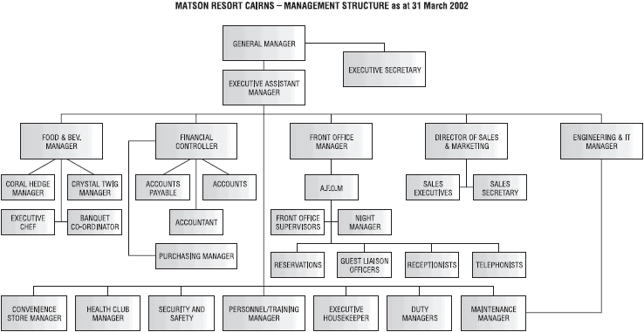

Figure 2 E Travel Week (2002)

The plan developed by the hotel to be able to implement smoothly, the need for each unit in the organization, each member in the implementation of the work to form a reasonable division of labor relations.

**Conclusion**

In this assignment, I learn about company human resources outsourcing as an important breakthrough in the new situation, in the company human resources to achieve rapid development, company in reducing business costs, enhance their service industries, innovative new models at the same time, to enhance their economic efficiency, while internal staff In the medical insurance, to encourage treatment, the working environment and many other aspects have been a certain amount of protection, while enhancing the role of their own brand, so that companies in the community have a good reputation, enhance the competitiveness of enterprises in the industry. But like other reforms, the implementation of human resource management outsourcing is that there are some risk factors that cannot be ignored. In particular, the scope of human resources management is extensive, and business, social phenomena are closely related, if the decision-making mistakes, the loss is difficult to make up. This paper studies the human resource management talent outsourcing strategy has great theoretical significance and practical value. But because of my level and ability to limit the collection of this paper is not very comprehensive, relatively vague collection, the lack of subjective judgments, this is the shortcomings of this paper, hope that I can overcome the difficulties in the human resources management outsourcing decision Model design to achieve further improved results.

**References**

1.INDEX MUNDI (2016) (ONLINE) SINGAPORE POPULATION RETRIVED FROM :[http://www.indexmundi.com/singapore/age_structure.html](mailto:http://www.indexmundi.com/singapore/age_structure.html)

2. E TRAVEL WEEK (2002) (ONLINE) ORGANIZATIONAL CHART FOR LEISURE FIRM RETRIVED FROM:

[https://etravelweek.com/imported/leisure-industry-organizational-structure-and-design](mailto:https://etravelweek.com/imported/leisure-industry-organizational-structure-and-design)

THE END